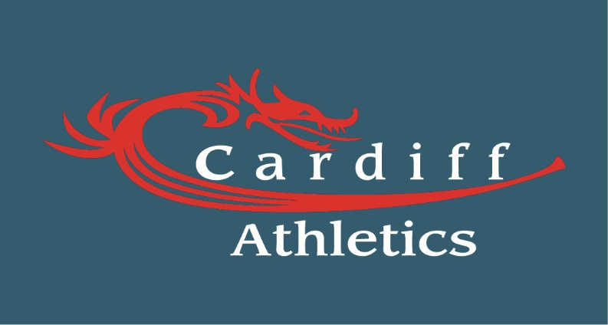

Cardiff Athletics
UK Youth development League
Upper and Lower Age Group

Selection Guidelines

Overview
1. Cardiff Athletics takes a strategic approach to the UK Youth Development League Upper and Lower age group competitions to reflect our ultimate aim of being a regular participant in the national finals. Whilst it is important that the Cardiff Athletics team is successful in the UK Youth Development League itself, we also recognise its importance as a learning experience for the athletes and to building the foundations for a successful pathway to the senior teams.
Cardiff Athletics YDL Teams
2. As at 1st January 2019 Cardiff Athletics will form four UK Youth Development Teams;
a. Lower Age Group Female (U13 &U15)
b. Lower Age Group Male (U13 &U15)
c. Upper Age Group Female (U17 & U20)
d. Upper Age Group Male (U17 &U20)
Team Selection Process
3. The Teams will be selected, from the top two Cardiff Athletes from:
a. Power of ten current club standing.
b. Current form and fitness – Coach liaison
c. Availability.
4. The Teams are not fixed, as it is a competitive squad and as results and performances start to be produced so does the So does the Team.
a. For Example, an individual not in the top two in of the power of ten produces an outstanding time, height or distance and moves the athlete to into the top two within the club ranking on the Power of Ten, thus the individual is promoted to the team and the athlete moved down to a place is moved into Welsh Junior league selection. This allows the Team to be selected from the best current athletes on form.
5. Athletes must declare their availability to the selection panel once the fixtures are released for the season, Athletes must prioritise the UK Youth Development League Fixtures. Only fixtures that supersede UK Youth Development League are International selection on the date of the fixture.
8. Team Managers must liaise with athletes’ coaches prior to selection for confirmation on form, fitness and injuries.
9. Once Teams are provisionally selected the Team Managers must notify the club thus enabling to support the Team Manager selection. The team will be announced 14 days prior to the fixture.
10. Athletes can only withdraw from the fixture through injury/illness, at which point the next member would be selected as the replacement.
10. Athletes who withdraw through no other reason than injury/illness, will be released from the team and not selected for the remaining fixtures.
11. Athletes who fail to represent the club when selected on three occasions, will have their membership reviewed and possible withdrawn.
Regional and National finals
12. Athletes can only be selected for the Regional and National finals if they have competed in at least one UK Youth Development League fixture and still meet all other selection criteria.
Competition Opportunities for Squad Selection
13. Cardiff Athletics will be promoting a number of competition opportunities in a variety of events (including combined events) to help athletes achieve selection criteria to allow for squad selection. To facilitate head-to head performances, athletes will be encouraged to participate in competition opportunities against their peers. Athletes who choose not to compete in such competition opportunities may harm their chances of selection.
a. Welsh Junior League (WJL).
b. Welsh Senior League (WSL).
c. Open events.
d. School events.
Conditions
14. Performances must be achieved during competitions organised or authorised by UK Athletics (UKA), its Area Associations (Welsh Schools) or its National Governing Bodies (Welsh Athletics).
15. Wind-assisted performances (or performances achieved at events where wind measurement was not available) will not be accepted. The interpretation of a wind assisted Combined Events performance will be based on the most recent version of the UKA rules for competition book (at the time of selection), unless the relevant organising committee state otherwise.
16. Hand-timed performances in 100m, 200m, 400m, 800m, 100m/110m Hurdles and 400m Hurdles will not be accepted.
17. Indoor performances for all field events and for races of 400m or longer will be accepted.
18. The Club and Team Managers reserve the right to make value judgments on situations that they consider to be exceptional circumstances that meet with selection Criteria within the policy.
19. All questions related to the selection policy or competition opportunities should be directed to Club Manager, Mark Gold (office@cardiffaac.org) or Head of Youth Development, TBC (HoYD@cardiffaac.org).

Amendment
20. Cardiff Athletics reserves the right to amend this Selection Policy at its sole discretion and will make any amended version publicly available (including the date on which any amendment was made) at www.cardiffaac.org.

Management Committee
Cardiff Athletics

