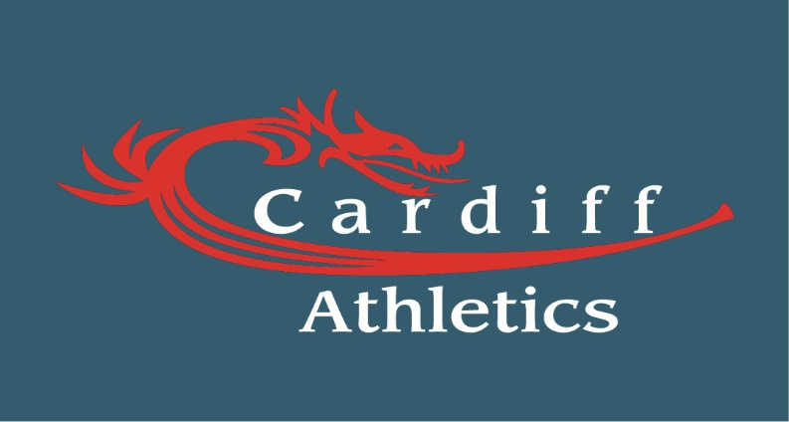

Cardiff Athletics
Welsh Junior League

Selection Guidelines

Overview
1. Cardiff Athletics takes a developmental approach to the Welsh Junior League competitions to reflect our ultimate aim of reaching the Cup Final. Whilst it is important that the Cardiff Athletics team is successful in the Welsh Junior League itself, we also recognise its extreme importance as a learning and developmental experience for the athletes and building team spirit, thus building the foundations for a successful pathway to the UK Youth Development teams.
Welsh Junior League Teams
2. Cardiff Athletics will have teams competing in the following age groups:
a. Under 11 Boys.
b. Under 11 Girls.
c. Under 13 Boys.
d. Under 13 Girls.
e. Under 15 Boys.
f. Under 15 Girls.

Welsh Junior League Selection Process
3. Cardiff Athletics can select a maximum four athletes per event per age group.
4. Athletes must declare their availability to the selection panel once the fixtures are released for the season, Athletes must prioritise the Welsh Junior League fixtures, if they wish to progress to the UK Youth Development League Squad. Only fixtures that supersede the Welsh Junior League are International selection on the date of the fixture.
Team Selection
5. Athletes will be selected based on the Team managers consideration of a combination of the following criteria as well as any other factors that may be deemed relevant.
a. The Team Manager will select the four Athletes allowing for development from the following criteria;
i. Power of Ten
ii. Coach recommendation for development
iii. Current form.
iv. Current fitness.
v. Injury concerns.

6. The Team Manager must liaise with athletes’ coaches prior to selection for confirmation on form, fitness and injuries.
7. Once Teams are provisionally selected the Team Managers must notify the club thus enabling to support the Team Manager selection. The Team will be announced 14 days prior to the fixture.
8. Athletes can only withdraw from the fixture through injury/illness, at which point the next development athlete member would be selected as the replacement.
9. Athletes who withdraw through no other reason than injury/illness, will be not selected for the remaining fixtures.
10. Athletes who fail to represent the club when selected on three occasions, will have their membership reviewed and possibly withdrawn.
Cup and Plate finals
11. Athletes can only be selected for the Cup or Plate finals if they have competed in at least one Welsh Junior League fixture and still meet all other selection criteria.
Competition Opportunities for Squad Selection
12. Cardiff Athletics will be promoting a number of competition opportunities in a variety of events (including combined events) to help athletes achieve selection criteria to allow for squad selection. To facilitate head-to head performances, athletes will be encouraged to participate in competition opportunities against their peers. Athletes who choose not to compete in such competition opportunities may harm their chances of selection.
a. Open events.
b. School events.
c. Quad Kids.
d. Academy open event.

13. The Club and Team Managers reserve the right to make value judgments on situations that they consider to be exceptional circumstances that meet with selection Criteria within the policy.
15. All questions related to the selection policy or competition opportunities should be directed to Club Manager, Mark Gold (office@cardiffaac.org) or Head of Youth Development, TBC (HoYD@cardiffaac.org)
Amendment
16. Cardiff Athletics reserves the right to amend this Selection Policy at its sole discretion and will make any amended version publicly available (including the date on which any amendment was made) at www.cardiffaac.org.

Management Committee
Cardiff Athletics

